MiSACWIS Project

CM40 – Maintain Case Recording Screen Specification

Version 2.21

May 4, 2016

Prepared for:


120 N. Washington Square
SACWIS Project, 8th Floor
Lansing, MI 48933

Prepared by:

Revision Log
Version | Date | A/D/C (Add, Delete, Change) | Author | Document Section # | Description
0.1 | 11/18/2011 | A | N Page |  | Initial version
0.2 | 11/20/2011 | C | N Page | 3.1.2, 3.2.2 | New To Be screens
0.3 | 11/21/2011 | C | N Page |  | Updates based on session
0.4 | 11/22/2011 | C | N Page |  | Updates based on session
0.5 | 11/23/2011 | C | N Page | 3.1.2, 3.3.2 | New To Be screens
0.6 | 11/25/2011 | C | N Page | 3.2.2 | New To Be screen
0.7 | 11/26/2011 | C | N Page | 3.2.2 | Changed order of Purpose rows
0.8 | 11/28/2011 | C | N Page |  | Updates based meeting.
0.9 | 11/29/2011 | C  C | N Page  S Kulkarni | 3.1.3,3.2.3 | Updates based on meeting  Updated field grids
0.10 | 11/30/2011 | C | N Page | 3.1.2, 3.2.2  3.4.2 | Change Control #1993  New To Be screens  Put Addendum back in
0.11 | 12/1/2011 | C | S Kulkarni | 3.1.3,3.2.3 | Updates based on meeting  Updated field grids
0.12 | 12/04/2011 | C | N Page | 3.2.8  3.2.2  3.2.3 | Corrected Ref Values for duration – time ranges  Removed Contact Subtype
0.13 | 12/05/2011 | C | N Page | 3.2.8  3.4.8, 3.5.8 | Changed Ref Vas and added BR regarding second narrative box
0.14 | 12/12/2011 | C | N Page | Many | Changed “Case Recording” to “Social Work Contact” throughout.
1.0 | 12/12/2011 | C | N Page |  | Approved
1.1 | 12/16/2011 | C | N Page | 3.1.3, 3.2.3, 3.2.8 | Change Control# 2560  Ref Vals  Quality Assurance Review. No functionality impact.
1.2 | 12/27/2011 | C | S Kulkarni  N Page | 3.1.3, 3.2.3  3.2.4, 3.1.8  3.2.8 | Change Control# 2560  Quality Assurance Review. No functionality impact
1.3 | 12/29/2011 | C | N Page |  | Approved  All revisions accepted
1.4 | 01/04/2012 | C | B. Palmer-Scott | 1 | Updated purpose to match edited use case description
1.5 | 01/19/2012 | C | N Page | 2.3 | Change Control #3296  Security Grid set to standards
1.6 | 01/21/2012 | C | N Page | 3.2.2  3.2.3, 3.2.4 | Change Control #3244  Copy to Resource
1.7 | 01/25/2012 | C | N Page | 2.8 | Change Control #1503  Add Req 60070
1.6 | 01/27/2012 | C | Sangeetha Rajan | 3.2.3 | Change Control #3244  Screen grids
1.7 | 02/28/2012 | C | Sangeetha Rajan  N Page | 3.2.2, 3.2.3  3.1.2, 3.1.3  3.2.2, 3.2.3,  3.2.8 | Change Control#4869 Added New Screen and updated Screen grids
1.8 | 03/05/2012 | C | Sangeetha Rajan | 3.1.3, 3.2.3 | Change Control#4869 Added New Screen and updated Screen grids
1.9 | 03/28/2012 | C | N Page | 2.2, 3.1.5, 3.2.2, 3.2.3, 3.2.5, | Change Control # 4766, 6787, 6791
1.10 | 05/18/2012 | C | P. Rasher | 3.1.3, 3.1.8, 3.2.8 | Change Control # 9490
1.11 | 06/01/2012 | C | N Page | 2.2  2.7, 2.8 | Change Control #10538  Change Control #9927
1.12 | 06/04/2012 | C | N Page | 3.2.5 | Change Control #9927
1.13 | 06/26/2012 | C | N Page | 3.1.3, 3.2.3 | Change Control #12862
1.14 | 07/06/2012 | C | N Page |  | Change Control #13475
1.15 | 09/18/2012 | C | N Page | 2.7, 2.8 | Change Control #18460
1.16 | 09/28/2012 | C | N Page | 3.1.3,  3.1.5, 3.1.6, 3.2.3, 3.2.6, 3.3.2,  3.3.3, 3.3.5, 3.3.6,  3.4.3, 3.4.6, 3.5.3, 3.5.6 | Change Control # 19118
1.17 | 10/16/2012 | A | S Seales | 2.2 | Change Control #16399  Added BR 3
1.18 | 11/05/2012 | C | P. Rasher | 2.10, 3.1.2, 3.1.4 | CC# 21384 report hyperlink  CC#21400 Contact Participant label
1.19 | 11/13/2012 | C | N Page | 3.1.3, 3.2.3 | Change Control # 22655
1.20 | 02/15/2013 | D | Samaad Seales | 2.1.7 | CC#28328
1.21 | 04/16/2013 | C | P. Rasher | 3.2.3 | CC#4886 Copy to Case
1.22 | 04/24/2013 | C | P. Rasher | 3.1.2, 3.1.4 | CC#32183 disable Print, Print All
1.23 | 05/21/2013 | C | P. Rasher | 3.2.2, 3.2.3, 3.3.3, 3.5.3 | CQ#7208 CaseActivityNarrative. ActivityNote, ActivityNoteNotPrinted are CLOBs
1.24 | 06/25/2013 | C | P. Rasher | 3.1.5 BR#4, 3.2.5 BR#2 | CQ#32183 complete revisions for disabled Print, Print All buttons
2.0 | 05/29/2014 | A | P. Rasher | 3.1.5#21, 22, 23 | CC#54716 Display SWC for investigations and intakes
2.1 | 06/17/2014 | C | S. Seales | 3.3, 3.3.3 | CQ#51134 added person_id to the
2.2 | 06/26/2014 | A, C | P. Rasher | 2.4, 3.3.2, 3.3.3, 3.3.4, 3.2.5 | CC#60366/58600 Access from CPS Intake Social Work Contacts tab, Restore Person Search, Add buttons to S03
2.3 | 07/17/2014 | C | M. Stubbs | 3.3.5.5 | CC#40429  Modified BR to support inclusion of Associate Persons in SWCs.
2.4 | 07/21/2014 | A, C | P. Rasher | 3.1.2, 3.1.4, 3.1.5#4, 3.2.5#2 | CC#33667 SWC Log report - Print, Print All
2.5 | 04/02/2015 | A, C | P. Rasher | 3.2.2, 3.2.4, 3.2.5#29 | CC#82837 Add Archive buttons for the Narrative and Additional Narrative fields.
2.6 | 05/11/2015 | A | Mark Van Hoose | 3.1.5 #24, 25 | JJ User Story # 121
2.7 | 06/15/2015 | A | Mark Van Hoose | 3.3.5 #8 | JJ User Story # 277
2.8 | 08/07/2015 | A | Joe Hart | 3.2.5 #30 | CC#75804 Additional business rule for Parent/Child Visit Contact Type
2.9 | 08/19/2015 | C | Joe Hart | 3.2.5 #30 | CC#75804 Additional specification for business rule #30 for Parent/Child Visit Contact Type
2.10 | 10/28/2015 | A, C | J. Hart | 2.7  3.2.2  3.2.3  3.3.2  3.3.3  3.3.5 #9, 10 | CC# 90378  New tickler:  - SWC record is due in 30 days after Removal record completion  Two new Activity Purpose Checkboxes:  - Foster Child Bill of Rights  - Interview With Youth On Return From AWOLP  New question with Yes/No drop-down for each Child(ren) and Case Members on Participants screen  New business rules in section 3.3.5 #9, 10
2.11 | 11/18/2015 | A | J. Hart | 2.7 | CC# 100683  New Tickler:  - Annual FC Bill of Rights SWC Record Completion
2.12 | 11/25/2015 | C | J. Hart | 2.7 | CC#100683 Updated removal business rule.
2.13 | 12/14/2015 | C, D | J. Hart | 2.2  3.1.2  3.2.3 | CC#102734 Updated Class Attribute Name for Provider in section 3.2.3 and removed BR#2 from section 2.2  CC#102831 Updated the To Be Screen in section 3.1.2 to copy the three buttons: “Add SWC”, “Print”, and “Print All”.
2.14 | 12/17/2015 | C | J. Hart | 3.2.5 | CC#103394 Updated Section 3.2.5 BR#9
2.15 | 12/18/2015 | C | J. Hart | 3.2.5 | CC#97111 Updated section 3.2.5 BR#6 and #14.  CC#103394 Updated Section 3.2.5 BR#9
2.16 | 01/05/2016 | C | J. Hart | 3.2.5 | CC#104065 Updated section 3.2.5 BR#9
2.17 | 01/20/2016 | C | J. Hart | 2.3  3.1.5 | CC#104703 Updated Security Requirements #4  Modified 3.1.5 BR#20
2.18 | 01/27/2016 | C | J. Hart | 3.1.5.20 | CC#104703 A second update to 3.1.5 BR#20 was needed
2.19 | 02/03/2016 | C | J. Hart | 3.1.5.20 | CC#104703 A third update was needed for 3.1.5 BR#20 regarding JJ residential records.
2.20 | 02/29/2016 | A, C | J. Hart | 2.7  3.2.5.9  3.3.5.11 | CC#106260 a new business rule for section 3.3.5.11  CC#106433 modification to business rule 3.2.5.9  CC#107578 addition of new tickler rules to 2.7.
2.21 | 05/04/2016 | A, C | Mark Van Hoose | 2.7, 3.3.5.8 | CC#112716 – Residential Add Person Button  CC#112834 – Update Ticklers

Table of Contents
MiSACWIS Project 1
Version 2.4 1
Revision Log 2
Table of Contents 6
List of Figures 8
1 Introduction 9
1.1 Purpose 9
1.2 Scope 10
2 Use Case Details 11
2.1 Action Buttons/Hyperlinks 11
2.2 Business Rules 11
2.3 Security Requirements 13
2.4 Screen Navigation 13
2.5 Tab Order 14
2.6 Pre-Conditions 15
2.7 Ticklers 16
2.8 Notifications 18
2.9 Calendar 20
2.10 Reports 20
2.11 Notes and Assumptions 20
3 Screen Details 22
3.1 Social Work Contacts Search & Log 22
3.1.1 As Is – Case Recording Search & Log 22
Figure 1 – As Is - Case Recording Search & Log 22
3.1.2 To Be – Social Work Contact Search & Log 23
Figure 2 – To Be –Social Work Contact Search & Log 23
3.1.3 Screen Fields 24
3.1.4 Action Buttons/Hyperlinks 29
3.1.5 Business Rules 30
3.1.6 Screen Navigation 37
3.1.7 Pre-Conditions 37
3.1.8 Reference Values 37
3.2 Social Work Contact Detail 38
3.2.1 As Is – Case Recording Detail 38
Figure 3 – As Is – Case Recording Detail 39
3.2.2 To Be – Social Work Contact Detail 40
Figure 4 - To Be - Social Work Contact Detail 41
3.2.3 Screen Fields 42
3.2.4 Action Buttons/Hyperlinks 51
3.2.5 Business Rules 52
3.2.6 Screen Navigation 61
3.2.7 Pre-Conditions 61
3.2.8 Reference Values 61
3.3 Select Participants Screen 62
3.3.1 As Is – Select Participants Screen 62
Figure 5 – As Is - Select Participants 62
3.3.2 To Be – Select Participants Screen 63
Figure 6 – To Be – Select Participants for Investigation and Case 63
Figure 6 – To Be – Select Participants for Intake 64
3.3.3 Screen Fields 65
3.3.4 Action Buttons/Hyperlinks 69
3.3.5 Business Rules 69
3.3.6 Screen Navigation 73
3.3.7 Pre-Conditions 73
3.3.8 Reference Values 73
3.4 Social Work Contact Addendum Details Screen 74
3.4.1 As Is – Case Recording Addendum Details Screen 74
Figure 7 – As Is – Case Recording Addendum Details 74
3.4.2 To Be – Social Work Contact Addendum Details Screen 75
Figure 8 - To Be Social Work Contact Addendum Details 75
3.4.3 Screen Fields 76
3.4.4 Action Buttons/Hyperlinks 77
3.4.5 Business Rules 77
3.4.6 Screen Navigation 78
3.4.7 Pre-Conditions 79
3.4.8 Reference Values 79
3.5 View Full Narrative Screen 80
3.5.1 As Is – Full Narrative Screen 80
Figure 9 – As Is - View Full Narrative Screen 80
3.5.2 To Be – View Full Narrative Screen 81
Figure 10 - To Be - View Full Narrative Screen 81
3.5.3 Screen Fields 82
3.5.4 Action Buttons/Hyperlinks 83
3.5.5 Business Rules 83
3.5.6 Screen Navigation 85
3.5.7 Pre-Conditions 85
3.5.8 Reference Values 85

List of Figures

Figure 1 – As Is - Case Recording Search & Log 22
Figure 2 – To Be –Social Work Contact Search & Log 23
Figure 3 – As Is – Case Recording Detail 40
Figure 4 - To Be - Social Work Contact Detail 42
Figure 5 – As Is - Select Participants 63
Figure 6 – To Be – Select Participants for Investigation and Case 65
Figure 6 – To Be – Select Participants for Intake 66
Figure 7 – As Is – Case Recording Addendum Details 75
Figure 8 - To Be Social Work Contact Addendum Details 76
Figure 9 – As Is - View Full Narrative Screen 81
Figure 10 - To Be - View Full Narrative Screen 82

Introduction

Purpose
In MiSACWIS, social work contacts are a central part of case management. Social work contacts are used to log contacts made or attempted, not only with case members but also with any person associated with a case. Social work contacts provide a powerful way for workers to document the details of scheduled and unscheduled contacts. The contacts that are logged include communication with children and youth on a case, their care givers, teachers, neighbors, and other collateral informants. Social work contacts are included in service plans. These service plans, generated on a regular basis (30 days from inception in both foster case and CPS and every 90 days thereafter), can then be shared with interested parties such as foster parents, the courts and other workers.
Social work contacts can be accessed from the sidebar navigation pane as well as from the Investigation Topics page (use case IV20 – Maintain Investigation) and Visitation Plan page (use case CM09 – Record Visitation Plan). When first accessing social work contacts, users are presented with the Social Work Contact Search and Log page, which contains a very extensive set of fields on which users can filter the social work contacts for a case.
Beneath this is the Social Work Contact Log which contains data about the social work contacts for the case: date, time, contact type, contact method, and participants, listed in reverse chronological order.
From this page, users can choose to view an existing social work contact or create a new one. Either way, the Social Work Contact Detail page is displayed. On this page, users enter data, including the contact date and time, whether the contact was scheduled and whether it occurred, and if it did, where it occurred. In addition to entering the contact type (Parenting Time, Sibling Visit, Investigation Commencement, etc.) users can enter other possible functions of the contact, including engagement of services, notification of legal proceedings and supervisor shadowing. There are also two Narrative boxes on this page in which to enter the main content of the contact. One of the boxes will be included in the ISP (initial service plan), USP (updated service plan) and PWSP [permanent ward (of the court) service plan]. The other box is for more sensitive material that needs to be documented but not shared with the service plan audience.
The Social Work Contact Detail page also displays the participants in this social work contact, as well as a hyperlink to go to the page where more participants can be added – the Select Participants page. In the Select Participants page, users are presented with the name(s) of the child(ren) on the case, whether the contact was a private meeting, other case members, and associated persons on the case.
Another function available on the Social Work Contact Detail page is copy functionality. This allows users to copy the social work contact to another case or investigation Users can enter the case or investigation ID of the case meant to share the social work contact and if needed, click the “Case/Investigation Search” button to verify the ID.
Once a social work contact can no longer be edited (status is no longer “Draft”) users can still add corrections and additional information by using the addendum functionality. By clicking on the “Add Social Work Contact Addendum” button, users are taken to the Social Work Contact Addendum Details page where they can view the existing narratives on the top of the page and can add a narrative on the bottom . Back at the Social Work Contact Detail page, users can select the “View Full Narrative” button to view all narratives entered for the social work contact – the original narratives, any updates and any addendums.

Scope
The scope of this document is the set of screen specifications related to the Social Work Contact functionality in MiSACWIS.

Use Case Details

Action Buttons/Hyperlinks
Status (Keep/Add/  Modify/Delete) | Label | Type | On Click Action/Navigation
Keep | Help | Hyperlink | Screen level Help appears in a separate browser window.

Business Rules
No. | Status (Keep/Add/  Modify/Delete) | Business Rule Description | Modified Business Rule Description | Execution Event (field tab out/save etc) | Error Msg Code  To be completed by Development Team
1 | Modify | Social Work Contacts will be set to “Completed by System” after 90 days. | Social Work Contacts will be set to “Completed by System” after 120 days.
2 | Delete | When Social Work Contacts are linked to Amendment/Expungement records, and the Amendment/Expungement record is deleted, these Social Work Contacts should be unlinked from the Amendment/Expungement record but remain linked to the case. |  | User clicks the “delete” hyperlink on IV07 S01 or S02.
3 | Add | When navigating from CM09:  Users will not be permitted to add new instances of the Social Work Contacts to the Visitation Plan. Users will be permitted to link Social Work Contact records where the Activity Date of the record is equal to or greater than the Effective Date of the Visitation Plan and less than or equal to the End Date of the Visitation Plan |  | Apply/save

Security Requirements
No. | Status (Keep/Add/  Modify/Delete) | Security Requirement
1 | Keep | Create  Foster Care Worker has the rights to Create  Clerical has the rights to Create
2 | Keep | Read  Worker has the rights to Read
3 | Keep | Update  Foster Care Worker has the rights to Update  Clerical has the rights to Update
4 | Modify | Delete  Foster Care Worker has the rights to Delete  Clerical has the rights to Delete

Screen Navigation
No. | Status (Keep/Add/  Modify/Delete) | To Screen Navigation Path
1 | Keep | Case Overview > select a non Investigations case > Social Work Contact
2 | Keep | Case Overview > select an Investigations case > Investigation Topics > Social Work Contact
3 | Add | CPS Intake > Social Work Contacts tab

Tab Order
No. | Status (Keep/Add/  Modify/Delete) | Screen name
1 | N/A

Pre-Conditions
No. | Status (Keep/Add/Modify/Delete) | Pre-Condition
1 | Keep | Case must be in MiSACWIS

Ticklers

Status (Keep/Add/Modify/Delete) | Tickler Name | Trigger Action | Tickler Generation Business Rule & Description | Tickler Removal Business Rule | Tickler Text
Status (Keep/Add/Modify/Delete) | Tickler Role
Add | Mandated Contact | 7 business days before end of month | Child has Program Type = ‘Foster Care’ with no End Date  And  Child has no record for current month where  - Method: Face to Face  - Participants:  - Child’s Primary Foster Care Worker  If there is one, else case level Primary Foster Care Worker  - Child | Appropriate Social Work Contact record is created. | A required Face to Face contact with [child’s name] has not been recorded for this month.
Add | Child’s Primary Foster Care Worker
Add | JJS Visit for Ongoing Placement | When there is a current non-completed ‘JJS Visit for Initial Placement tickler’ or a ‘JJS Visit for Ongoing Placement’ and a monthly face to face meeting for the youth is completed. | The due date will be end of the next month following the date of the social work contact. The tickler should first appear 7 days before the due date. It should have one escalation to a supervisor 2 days before the due date. | When a face to face visit with the youth is recorded  or the Juvenile Justice Program is closed  or a detention placement is recorded. | A required Face to Face contact with <Youth> has not been recorded for this month.
Add | Juvenile Justice Worker
Add | JJS Ongoing Visit in Detention, Same County | When there is a current non-completed ‘JJS Initial Visit in Detention, Same County’ tickler or a ‘JJS Ongoing Visit in Detention, Same County’ and a monthly face to face meeting for the youth is completed. | The due date will be end of the next month following the date of the social work contact. The tickler should first appear 7 days before the due date. It should have one escalation to a supervisor 2 days before the due date. | When a face to face visit with the youth is recorded  or the Juvenile Justice Program is closed  or a non-detention placement is recorded. | A required Face to Face contact with <Youth> has not been recorded for this month.
Add | Juvenile Justice Worker
Add | JJS Ongoing Visit in Detention, Different County | When there is a current non-completed ‘JJS Initial Visit in Detention, Different County’ tickler or a ‘JJS Ongoing Visit in Detention, Different County’ and a monthly face to face meeting for the youth is completed. | The due date will be end of the next month following the date of the social work contact. The tickler should first appear 7 days before the due date. It should have one escalation to a supervisor 2 days before the due date. | When a face to face visit with the youth is recorded  or the Juvenile Justice Program is closed  or a non-detention placement is recorded. | A required Face to Face contact with <Youth> has not been recorded for this month.
Add | Juvenile Justice Worker
Add | MARE with no identified family | Date MARE Recruitment record created + 80 days | Recruitment Family Name = blank and there is no Social Work Contact with the following characteristics:  - Purpose – Child Specific Recruitment Case Review meeting  - Method = Face to Face | Social Work Contact record with characteristics:  - Purpose – Child Specific Recruitment Case Review meeting  - Method = Face to face  OR  Family Name added to MARE Recruitment record | Because no family has been identified a Face to Face Social Work Contact with the Purpose of Adoption, Child Specific Recruitment, Case Review meeting must be entered.
Add | Adoption Worker
Add | Foster Child Bill of Rights Question | Completion of Removal Record | Completion of Removal Record (CM30) (not created in error). | Social Work Contact record entered after tickler creation date with Foster Child Bill of Rights question answered ‘Yes’ (CM40).  OR  If Removal Record is marked “Created in Error” (CM30). | [Child Name] A contact for Foster Child Bill of Rights due within 30 days of removal date.
Add | Annual Foster Child Bill of Rights SWC Record Completion | FC Program Type Begin Date +11 months. | Generated annually from removal date (triggered in CM30) while FC Program Type remains open. Tickler should display 30 days prior to due date. | A new SWC record created after disposition of Foster Child Bill of Rights Question tickler where the Foster Child Bill of Rights is answered Yes (CM40)  Or  Case is closed or FC program type is end dated. (CM17) Or  Removal record is marked Created in Error (CM30) | <Child Name> An Annual Contact for Foster Child Bill of Rights due within 30 days
Add | Foster Care Worker
Add | Funding Review - Reimbursability | On save of a ‘Completed’ reimburseability redetermination where the IV-E Reimburse Indicator value has changed. | If the system finds that:  - An active service auth exists (where status code = ‘Approved’ and Service End Date is either null or greater than equal to sysdate.  And  - The type is not ‘Initial’  And  - The IV-E Reimburse Indicator differs from the previous IV-E redetermination  Then generate tickler for immediate display.  *Note The tickler should use the Eligibility.personID to populate the Tickler.personID and the Reimburseabilitiy.reimburseabilityId to populate the Tickler.taskID.  The WorkloadItemId will be derived based on the EligiblityCaseID = Workload.workItemID and Workload.workItemTypeCode = ‘CASE. | Entry of a ‘Completed’ Social Work Contact where Contact Method (CaseActivityLog.contactTypeVal) = ‘Documentation’ and Contact Type (CaseActivityLog.contactTypeCodel) = Funding Review and Contact Date >= Tickler.createdDate | <Name, Person id> has a change in reimburseabilty that may impact his/her funding for case and/or placement services. Please review all active service authorizations and amend as necessary. Once review is completed, please enter a Social Work Contact indicating your funding review has been completed.
Add | Funding Review – Legal Status | On Termination of an existing Legal Status and Save of a new legal status where the Legal Status value has changed. | If the system finds that:  - An active service auth exists (where status code = ‘Approved’ and Service End Date is either null or greater than equal to sysdate.  And  - The current fund source is not ‘IV-E’.  Then generate tickler for immediate display.  *Note The tickler should use the LegalStatusInfo.childConcerning to populate the Tickler.personID and the LegalStatusInfo.legalStatusInfo Id to populate the Tickler.taskID.  The WorkloadItemId will be derived based on the EligiblityCaseID = Workload.workItemID and Workload.workItemTypeCode = ‘CASE. | A Social Work Contact where Contact Method (CaseActivityLog.contactTypeCode) = ‘Documentation’ and Contact Type (CaseActivityLog.contactTypeVal) = Funding Review | <Name, Person id> has a change in legal status that may impact his/her funding for case and/or placement services. Please review all active service authorizations and amend as necessary. Once review is completed, please enter a Social Work Contact indicating your funding review has been completed.

Notifications
Status (Keep/Add/Modify/Delete) | Notification Name | Trigger Action | Message Business Rule & Description | Message Text
Status (Keep/Add/Modify/Delete) | Notification Role | Trigger Action | Message Business Rule & Description | Message Text
Add | Mandated Contact | 7 business days before end of month | Child has Program Type = ‘Foster Care’ with no End Date  and  Child has no record for current month where  - Method: Face to Face  - Participants:  - Child’s Primary Foster Care Worker  If there is one, else case level Primary Worker  - Child | A required Face to Face contact with [child’s name] has not been recorded for this month.
Add | Primary Foster Care Worker  AND supervisor  AND  POS (Purchase of Service) monitor | 7 business days before end of month
Add | Social Work Contact Added | Social Work Contact created | Social Work Contact added to Case by somebody other than Primary Foster Care Worker. | <Name of person who created contact record> has created a Social Work Contact record for <Case ID>.
Add | Primary Foster Care Worker | Social Work Contact created
Add | Social Work Contact Updated | Social Work Contact edited | Social Work Contact created by or for the Primary Foster Care Worker is modified by anybody other than Primary Foster Care Worker (even modifications by the supervisor). | <Name of person who updated contact record> has updated a Social Work Contact record for <Case ID>.
Add | Primary Foster Care Worker | Social Work Contact edited
Add | Mandated Face to Face | 6 business days after start of month | Child has Program Type = ‘Foster Care’ with no end date  and  Child has no record for previous month where  - Method: Face to Face  - Participants:  - Child’s Primary Foster Care Worker  If there is one else case level Primary Worker  - Child | A required Face to Face contact with [child’s name] has not been recorded for last month.
Add | Primary Foster Care Worker  AND supervisor  AND  POS (Purchase of Service) monitor | 6 business days after start of month
Add | Addendum Added | A Social Work Contact Addendum is created | An Addendum is created for a Social Work Contact by a person other than the creator of the contact itself or the person for whom the contact itself was created. | “An addendum for a Social Work Contact in [case id] has been created.”
Add | Worker who created Social Work Contact or for whom it was created | A Social Work Contact Addendum is created
Add | Late Commencement | A Social Work Contact record with Purpose = Investigation has been created | Social Work Contact record with Purpose =Investigation Commencement has Contact Time (not create time) of more than 24 hours following intake create date/time. | Commencement of this investigation was not timely.
Add | Investigation worker and their supervisor |  |  | Commencement of this investigation was not timely.
Add | Investigation worker and their supervisor |  |  | Commencement of this investigation was not timely.

Calendar
Status (Keep/Add/Modify/Delete) | Calendar Name | Trigger Action | Calendar Event Generation Business Rule & Description | Calendar Event Date and Time Business Rule | Calendar Event Text
Status (Keep/Add/Modify/Delete) | Calendar Role
 | N/A

Reports
CM40 - Young Adult Monthly Visit Report (DHS-1295).
Possibly: Social Work Contacts (this is a Change Request)

Notes and Assumptions

- Requirement 58054 “The system must require Permanency Planning Conference when removal is being considered.”
is being handled by a BR in JJ13-Maintain Child and Family Team Meetings Screen Specifications.

The following Business Rule applies to FTM Type of “Considered Removal”:
The system shall create a Social Work Contact when the FTM record is completed and populate the Social Work Contact fields as follows: Contact Date = Date Meeting Occurred; Contact Type = FTM; Method = Meeting; Narrative = FTM Summary. Participants = Participated persons on FTM. If the children concerning attended in person, the Social Work Contact method will = Face to Face.

- One of the Ticklers defined in 2.7 calls for using the value of “Goal” on the child’s record. This value is drawn from Team 4 – Service Provision’s Use Case: CM37- Maintain Goals.

- Section 2.7 – Ticklers will need to be revisited after CM65-Maintain Exception Requests has been completed. The BRs for initialing some of the ticklers defined in this Use Case will need to include consideration of Exception Requests (for ex: if a parent is incarcerated then the Face to Face contact is not Mandated and therefore the worker should not receive a Tickler.)

As of 11/29/11 Team 2 has not received the detailed Exception Reasons from Policy Office and therefore we are not able to build the BRs.

Screen Details

Social Work Contacts Search & Log

As Is – Case Recording Search & Log
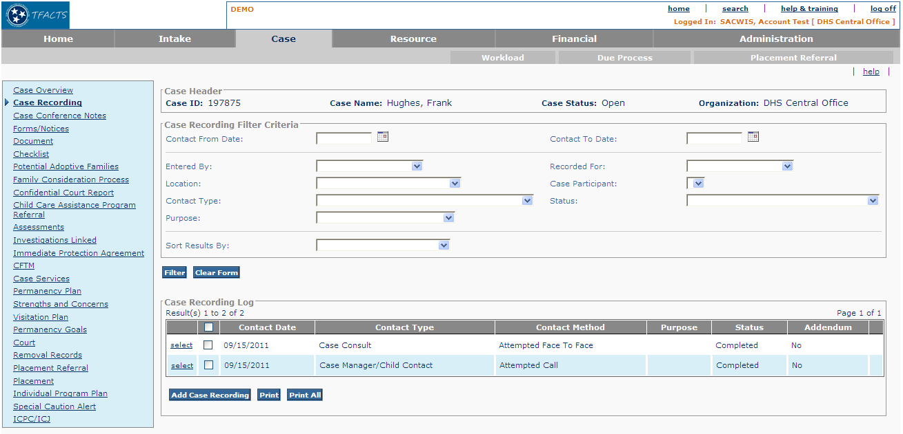

Figure 1 – As Is - Case Recording Search & Log

To Be – Social Work Contact Search & Log

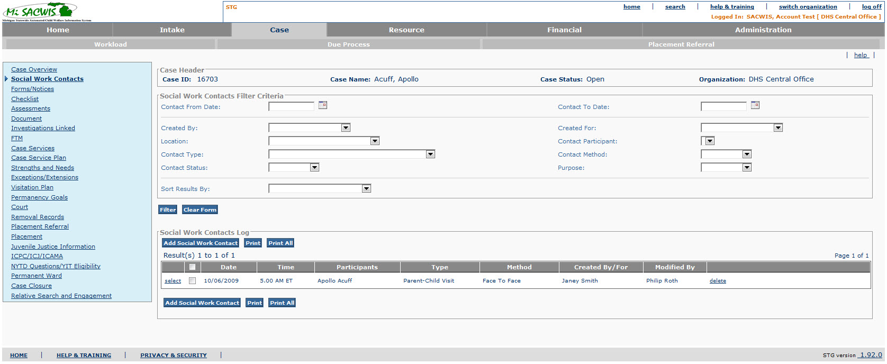

Figure 2 – To Be –Social Work Contact Search & Log

Screen Fields
Status (Keep/  Add/  Modify/  Delete) | As Is Class.Attribute Name | To Be Class.Attribute Name | As Is Display Name | To Be Display Name | To Be Type | To Be Align | To Be Size | To Be Read Only | To Be Calculation | To Be Edit Mask | To Be UI Validation
Keep | N/A | N/A | Case Header | Case Header  Or  Intake Header  Or  Investigation Header | Section Header | L | N/A | T | Navigating from Case:  Case Header  Navigating from Intake (IN01): Intake Header  Navigating from Investigation (IV20): Investigation Header | Use Standard Case Header  or Intake Header  Or Investigation Header  Format
Modify | N/A | N/A | Case Recording Filter Criteria | Social Work Contacts Filter Criteria | Section Header | L | N/A | T
Keep | CaseActivityLog.ActivityDate | CaseActivityLog.ActivityDate | Contact From  Date | Contact From  Date | Date | L | 10 | F |  | MM/DD/YYYY | User entered  Not required  Present calendar function
Keep | CaseActivityLog.ActivityDate | CaseActivityLog.ActivityDate | Contact To Date | Contact To Date | Date | L | 10 | F |  | MM/DD/YYYY | User entered  Not required  Present calendar function
Modify | N/A | CaseActivityLog.CreatedBy | EnteredBy | Created By | Drop down list | L | 100 | F | Person who created this record |  | User entered  Not required
Modify | CaseActivityLog.RecordedFor | CaseActivityLog.RecordedFor | Recorded for | Created For | Drop down list | L | 100 | F | Person for whom the recording is done |  | User entered  Not required
Keep | CaseActivityLog.Location | CaseActivityLog.Location | Location | Location | Drop down list | L | 100 | F | DomainCode=’ActivityLocationType’ |  | User entered  Not required
Modify | ActivityLogParticipant.ActivityParticipantId | ActivityLogParticipant.ActivityParticipantId | Case Participant | Contact Participant | Drop down list | L | 100 | F | Case or Investigation members |  | User entered  Not required  List of Social Work Contact Participants  on Social Work Contact records in this case
Keep | CaseActivityLog.ContactTypeCode | CaseActivityLog.ContactTypeCode | Contact Type | Contact Type | Drop down list | L | 100 | F | DomainCode=’ActivityContactType’ |  | User entered  Not required
Add | N/A | CaseActivitylog.ContactTypeVal | N/A | Contact Method | Drop down list | L | 100 | F | DomainCode=’ContactMethod’ |  | User entered  Not required
Modify | CaseActivityLog.ActivityStateCode | CaseActivityLog.ActivityStateCode | Status | Contact Status | Drop down list | L | 100 | F | DomainCode=’ActivityState’
Keep | CaseRecPurpose.purposeCode | CaseRecPurpose.purposeCode | Purpose | Purpose | Drop down list | L | 100 | F | Domain Code: ActivityPurpose
Keep | N/A | N/A | Sort Results By | Sort Results By | Drop down list | L | 100 | F | DomainCode=’ActivitySortBy’ |  | User entered  Not required
Modify | N/A | N/A | Case Recording Log | Social Work Contacts Log | Section Header | L | N/A | T
Keep | N/A | N/A | [checkbox] | [checkbox] | Checkbox | L | N/A | F |  |  | For each row, provide checkbox which when selected includes the record in the print report generation. If the checkbox is selected in the column header, the system must check all records in the list to print.
Modify | CaseActivityLog.ActivityDate | CaseActivityLog.ActivityDate | Contact Date | Date | Display text | L | 10 | T |  | MM/DD/YYYY | System derived  Display contact date for each record from case recording detail page
Add | N/A | CaseActivityLog.StartTime | N/A | Time | Display text | L | 10 | T |  |  | System derived  Display contact timefor each record from case recording detail  page
Add | N/A | ActivityLogParticipant.ActivityParticipantId | N/A | Participants | Display text | L | 150 | T | Participants are named – comma delimited
Modify | N/A | CaseActivityLog.ContactTypeCode | Contact Type | Type | Display text | L | 150 | T | Domain Code=’ActivityContactType’  See BR 3.1.5.1
Modify | CaseActivityLog.ContactMethodCode | CaseActivityLog.ContactTypeVal | Contact Method | Method | Display text | L | 150 | T | DomainCode=’ContactMethod’ |  | System derived
Delete | N/A | N/A | Purpose | N/A | Display Text | L | N/A | T
Add | N/A | CaseActivityLog.CreatedBy | N/A | CreatedBy/For | Display text | L | 100 | T |  |  | System derived
Add | N/A | CaseActivityLog.ModifiedBy | N/A | Modified By | Display text | L | 150 | T |  |  | Person who last modified the record
Delete | Activity_Log_Participant.Contact_Status_Code | CaseActivityLog.activityStateCode | Status | Status | Varchar2 |  | 30 | T |  |  | Display status of case recording- draft, completed
Delete | N/A | N/A | Addendum | Addendum | Grid column |  |  | T | Check if the addendum exists for this record. |  | For records in completed status- display if addendum added Y/N

Action Buttons/Hyperlinks
Status (Keep/Add/  Modify/Delete) | Label | Type | On Click Action/Navigation
Keep | Filter | Button | Filters the Activity records defining those that are to display in the Activity Log grid. The filter is based on the filter criteria selected.
Modify | Add Social Work Contact | Button | Presents the Social Work Contact Details page in create mode. Not available when navigating from IV07-S03 or CM09-S04.
Modify | Print | Button | Generates a Social Work Contact Log report that includes all of the selected Social Work Contact records from the Social Work Contact Log grid. Button not available when navigating from IV07-S03 or CM09-S04. This button will generate the CM40 – Social Work Contact Log Report.
Modify | Print All | Button | Generates a Social Work Contact log report that includes all Social Work Contact records that were pulled from filter search. Button not available when navigating from IV07-S03 or CM09-S04. This button will generate the CM40 – Social Work Contact Log Report.
Keep | Close | Button | Close button on screen when navigating from Investigation Topics. If coming to this page from Investigation Topics, the close button below the left side navigation pane returns actor to, Investigation Topics screen.
Modify | Select | Button | Available only if navigating from Visitation Plan. Once one or more Social Work Contacts are checked, the select will link the Social Work Contact to visitation plan and return the actor to the calling page. (Hide if coming from case navigation.)
Modify | Close | Button | Available only if navigating from Visitation Plan. If no Social Work Contacts are selected to link, the actor can select CLOSE to return to calling page. (Hide if coming from case navigation.)
Keep | Select | Hyperlink | Opens selected contact detail page in view or edit mode based on user security. If contact record status = completed, the only edit allowed is to add addendum.
Modify | Delete | Hyperlink | Deletes selected Social Work Contact record. Link is only available if Social Work Contact is in Draft status.
Add | Report | Hyperlink | Current screen data is cached and the system presents the Document Selection page CF18 - Manage Work Item Documents page.

Business Rules
No. | Status (Keep/Add/  Modify/Delete) | Business Rule Description | Modified Business Rule | Execution Event (field tab out/save etc) | Error Msg Code  To be completed by Development Team
1 | Add | Social Work Contact can be read by :  - Any DHS worker  - Any Private Agency worker whose agency is assigned to the case |  | Select
2 | Add | Social Work Contact can be created by  - Any DHS worker  - Any Assigned Private Agency Work whose organization (might be location specific) is assigned to the case  - Clerical with the Responsible Organization |  | Add Social Work Contact
3 | Add | In Social Work Contact Log grid “Created By / For” is the name of the person who created the Contact unless it was Created FOR somebody else –in which case it is that person’s name |  | Opening of page
4 | Keep | The system must allow the actor to select one to many case recording records from the Case Recording List page to view the print preview and/or print the case recordings. | The system must allow the actor to select one to many Social Work Contact records from the Social Work Contact List page to view the print preview and/or print the Social Work Contacts. | Print action
5 | Keep | Any number, and combination, of filter criteria fields can be used to perform a filter. |  | Filter action
6 | Keep | Only the case recording records that meet the filter criteria display in the Case Recording Log History grid. | Only the Social Work Contact records that meet the filter criteria display in the Social Work Contact Log History grid. | Filter action
7 | Keep | A future date cannot be entered in the ‘from’ or ‘to’ date filter criteria. |  | Filter action
8 | Keep | The contact Date can be less than OR equal to the current date. |  | Filter action
9 | Keep | “Contact From Date” the system will present all case recordings from that date to the current date.  “Contact To Date”, the system will present all case recordings from the first entry in the case to the selected date. | “Contact From Date” the system will present all Social Work Contacts from that date to the current date.  “Contact To Date”, the system will present all case recordings from the first entry in the case to the selected date. | Filter action
10 | Modify | The default sort order is “Case Recording Date (descending)”.  The default display will be the first 10 case recordings | The default sort order is “Social Work Contact Date (descending)”.  The default display will be the first 20 Social Work Contacts | Opening of page
11 | Modify | The Case Recording module must be available for all cases including Investigation, Ongoing, and Adoption Cases. | The Social Work Contact module must be available from the case level left navigation pane for all cases including Investigation, Ongoing, and Permanent Ward Cases. | N/A
12 | Keep | The List of Case recordings can be sorted by: Descending date order; Ascending Date Order; Status (completed, draft); Method (alphabetical); Type (alphabetical). | The List of Social Work Contacts can be sorted by: Descending date,  Method (alphabetical);  Type (alphabetical). | Filter action
13 | Delete | When navigating from IV07-S03, Due Process, the system must present the Select Button and the Close button and hide the Add Case Recording Button and the Print and Print All buttons. The checkboxes will be used to select individual case recordings to link to the selected due process record. When case recordings are checked and select button is clicked, the system must return the user to IV07-S03 and display all selected case recordings on the IV07-S03 page. |  | Page open event when navigating from IV07-S03
14 | Modify | When navigating from CM09-S04, Visitation Plan, the system must present the Select Button and the Close button and hide the Add Case Recording Button and the Print and Print All buttons. The checkboxes will be used to select individual case recordings to link to the selected visitation plan. When case recordings are checked and select button is clicked, the system must return the user to CM09-S04 and display all selected case recordings on the CM09-S04 page. | When navigating from, Visitation Plan, ISP/USP/PWSP the system will present the Select Button and the Close button and hide the Add Social Work Contact Button. The checkboxes will be used to select individual Social Work Contacts to link to the Service Plan. When Social Work Contacts are checked and select button is clicked, the system will return the user to the calling screen and display all selected Social Work Contacts. | Page open event when navigating from CM09-S04 or CM10
15 | Modify | When navigating from CM09-S04, Visitation Plan, the Case Recording filter criteria should have the ‘Contact From Date’ populated with the ‘Effective date’ of the visitation plan and the contact type values pre-filtered to include only these values: Sibling visit, Parent/Child Visit; Visit with Other Family Member/Kin; Private Provider/Parent-Child visit, Private Provider-Sibling Visit. | When navigating from Visitation Plan, the Social Work Contact filter criteria should have the ‘Contact From Date’ populated with the ‘Effective date’ of the visitation plan and the contact type values pre-filtered to include only these values: Sibling visit, Parenting Time, Visitation with Other Family Member, Visitation Plan Review. | Page open event when navigating from CM09-S04 or CM10
16 | Delete | When navigating from IV07-S03, Due Process, the Case Recording Filter Criteria should be pre-set with the Contact Type = Due Process. The system must allow the user to clear and change that pre-selected filter criteria. |  | Page open event when navigating from IV07-S03
17 | Modify | When navigating from IV07-S03 or CM09-S04, the system must hide and not present the left side case navigation on CM40-S01. | When navigating from Service Plan the system will hide and not present the left side case navigation on CM40. | Page open event when navigating from IV07-S03 or CM09-S04.
18 | Delete | When Contact type = Due Process, then display in the contact type grid column the associated contact subtype value selected on CM40-S02. |  | Filter/select and display of contact records.
19 | Modify | When navigating from IV20- S02, Investigation Case, the system must present the Add Case Recordings, Print, and Print All buttons on the list page. The system must hide and not present the left side case navigation on CM40-S01 and must enable a Close button to navigate the actor back to IV20-S02. | When navigating from CM10-Maintain Permanency Plan the system must present the Add Social Work Contacts buttons on the list page. The system must hide and not present the left side case navigation on CM40-S01 and must enable a Close button to navigate the actor back to the calling page. | Page open event from CM10 and click of close button.
20 | Modify | A Social Work Contact can be deleted only  - by the user who created it or the user for whom it was created  AND  - only until the ISP, USP, PWSP in which it has been included is sent for approval at which time the status of the Social Work Contact will be set to “Linked” | A Social Work Contact can be deleted only  For Case/Investigation/Residential Record  - by the user who created it or the user for whom it was created, supervisor assigned or the supervisor of any worker assigned to the case/investigation/residential record.  Supervisor for Residential Records Includes:  Role ID Role Name  505 School Administrator  507 Residential Supervisor  509 Residential Program Manager  510 Residential Director  512 Detention Program Manager  513 Detention Director  AND  - only until the ISP, USP, PWSP in which it has been included is sent for approval at which time the status of the Social Work Contact will be set to “Linked”  For Intake  - by the user who created it or the user for whom it was created  - Any CI supervisor will have the ability to delete a Draft SWC
21 | Add | Along with Social Work Contacts created within the case, the system will display all the social work contacts associated to the investigations linked to the case – using ASSOCIATED_CASE_LINK |  | Page load
22 | Add | Along with Social Work Contacts created within the case, the system will display all the social work contacts associated to the intakes linked to the case – using INTAKE_CASE_LINK |  | Page load
23 | Add | Along with Social Work Contacts created within the case, the system will display all the social work contacts associated to the intakes linked to the investigations linked to the case – using ASSOCIATED_CASE_LINK and Intake_Case_Link. |  | Page load
24 | Add | Only Social Work Contacts that were created by a user from the same organization as the Residential Record,  or  linked to an approved Juvenile Justice Service Plan in the current Juvenile Justice Program for the Youth that is the subject of the Residential Record  should appear in the new Social Work Contact search screen for Residential Records. |  | Page Load
25 | Add | Only social work contacts that has the Youth as a participant and attached to an approved JJ service plan should appear on the Residential record. |  | Page Load

Screen Navigation
No. | Status (Keep/Add/  Modify/Delete) | To Screen Navigation Path
1 | Keep | Case Overview > select a non Investigations case > Social Work Contact
2 | Keep | Workload > select an Investigations case > Investigation Topics > Social Work Contact
3 | Add | Investigation Workload > Social Work Contact

Pre-Conditions
No. | Status (Keep/Add/  Modify/Delete) | Pre-Condition
1 | Keep | A case (investigation, ongoing, adoption) has been created.

Reference Values
Please reference the XLS_REF_DATA spreadsheet located in the Michigan SACWIS > Project Library > Detail System Design Work In Progress > Team 0 Infrastructure > Database > Seed Data folder

Social Work Contact Detail

As Is – Case Recording Detail
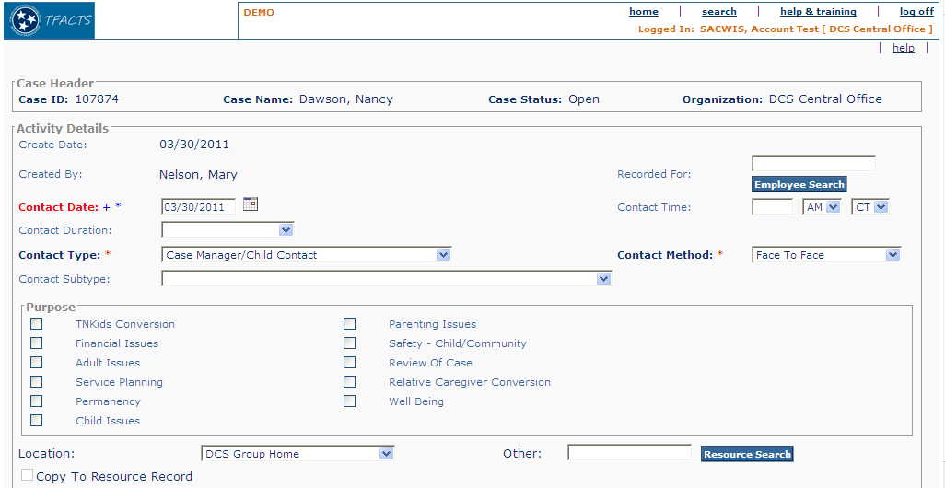

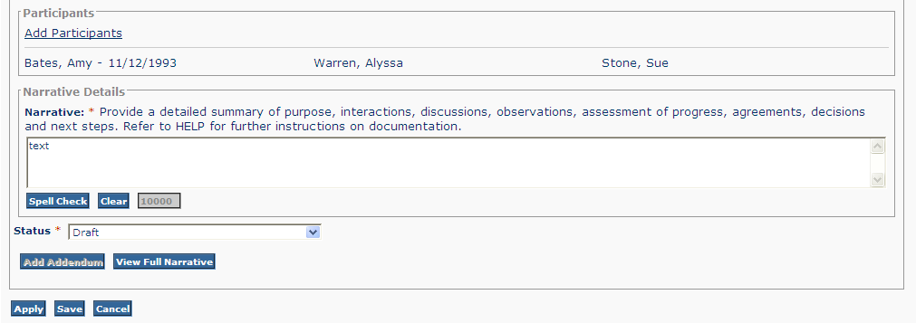

Figure 3 – As Is – Case Recording Detail

To Be – Social Work Contact Detail

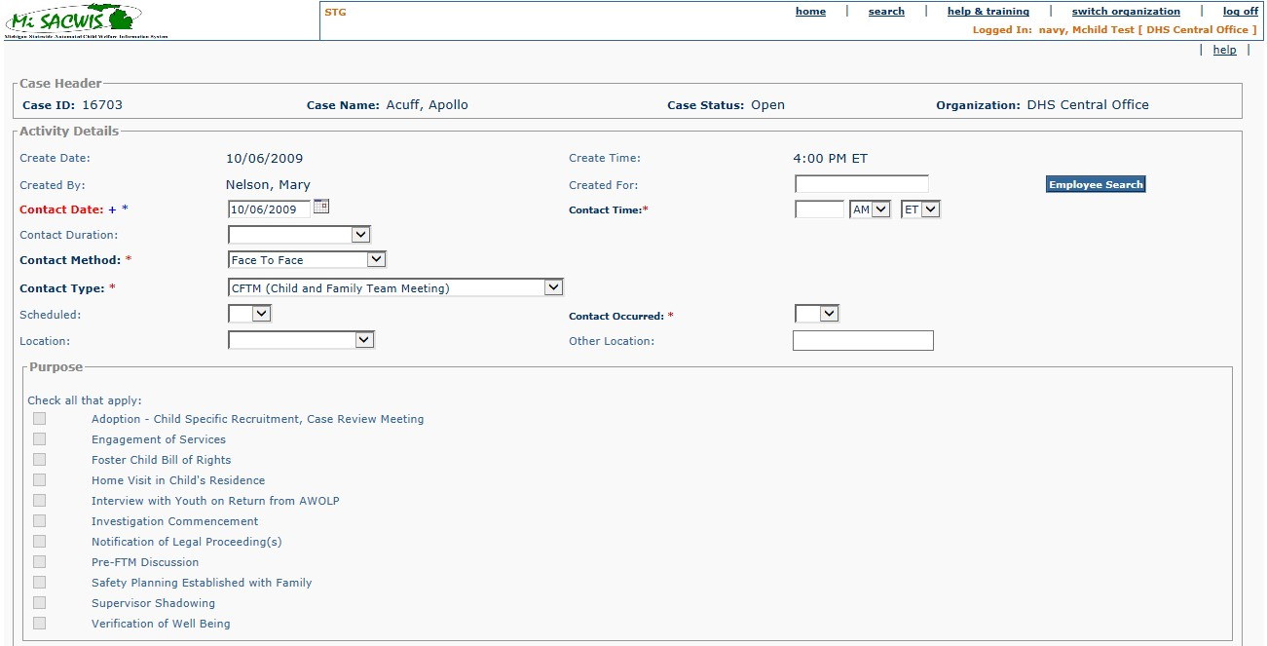
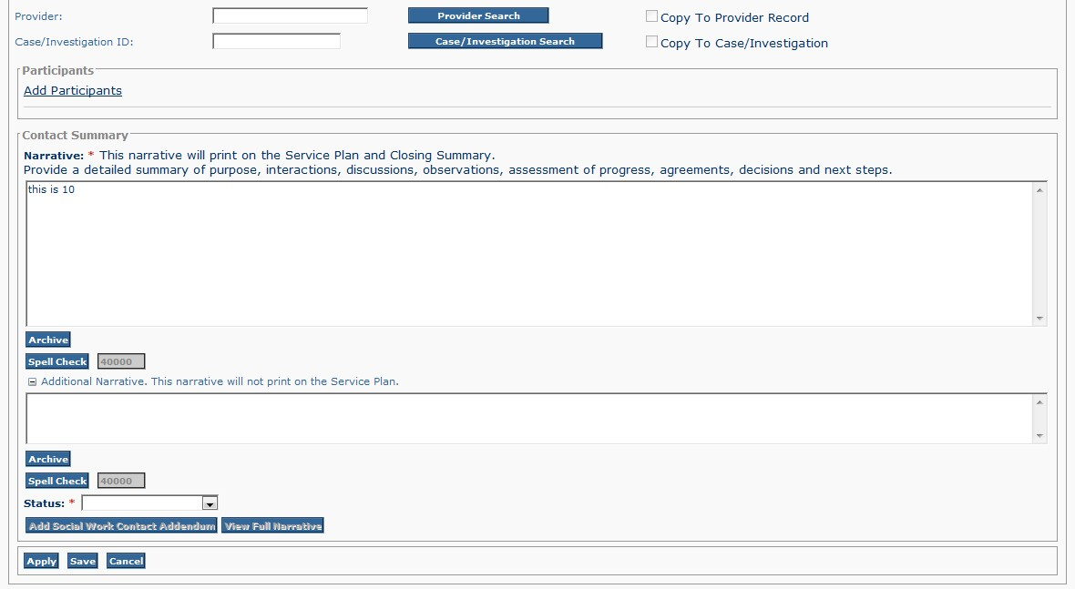

Figure 4 - To Be - Social Work Contact Detail

Screen Fields
Status (Unchanged/Add/Modify/Delete) | As Is Class.Attribute Name | To Be Class.Attribute Name | As Is Display Name | To Be Display Name | To Be Type | To Be Align | To Be Size | To Be Read Only | To Be Calculation | To Be Edit Mask | To Be UI Validation
Keep | N/A | N/A | Case Header | Case Header  Or  Intake Header  Or  Investigation Header | Section Header | L | N/A | T | Navigating from Case:  Case Header  Navigating from Intake (IN01): Intake Header  Navigating from Investigation (IV20): Investigation Header | Use Standard Case Header  or Intake Header  Or Investigation Header  Format
Keep | N/A | N/A | Activity Details | Activity Details | Section Header | L | N/A | T
Keep | CaseActivityLog.CreatedDate | CaseActivityLog.CreatedDate | Create Date | Create Date | Display text | L | 10 | T |  | MM/DD/YYYY
Add | N/A | CaseActivityLog.CreatedDate | N/A | Create Time | Display text | L | 10 | T |  | System Time  HH:MM | System displayed.  User cannot update.
Keep | CaseActivityLog.CreatedBy | CaseActivityLog.CreatedBy | Created By | Created By | Display Text | L | 22 | T
Modify | CaseActivityLog.RecordedFor | CaseActivityLog.RecordedFor | Recorded For | Created For | Text Field | L | 22 | F |  |  | User entered  Not Required;  Person search for users/employees to select and retrieve name if Social Work Contact being entered on behalf of another worker.
Keep | CaseActivityLog.ActivityDate | CaseActivityLog.ActivityDate | Contact Date | Contact Date | Date field | L | 10 |  |  | MM/DD/YYYY | User entered  Required  System will default to the current date
Keep | CaseActivityLog.StartTime | CaseActivityLog.StartTime | Contact Time | Contact Time | Time | L | 11 | F |  | HH:MM | User entered  Required
Keep | CaseActivityLog.startTime | CaseActivityLog.startTimeCode | (AM/PM) | (AM/PM) | Drop down list | L | 100 | F | DomainCode=’TimePeriod’ |  | User entered  Required
Keep | CaseActivityLog.startTime | CaseActivityLog.startTimeCode | (CT/ET) | (CT/ET) | Drop down list | L | 100 | F | DomainCode=’TimeZone’ |  | User entered  Required  Default ET
Keep | CaseActivityLog.ContactDurationCode | CaseActivityLog.ContactDurationCode | Contact Duration | Contact Duration | Drop down list | L | 100 | F | DomainCode=’ActivityContactDuration’ |  | User entered  Not required
Keep | N/A | CaseActivityLog.ContactTypeVal | Contact Method | Contact Method | Drop down list | L | 100 | F | DomainCode=’ContactMethod’ |  | User entered  Required
Keep | CaseActivityLog.ContactTypeCode | CaseActivityLog.ContactTypeCode | Contact Type | Contact Type | Drop down list | L | 100 | F | DomainCode=’ActivityContactType’ |  | User entered  Required
Delete | CaseActivityLog.SubCategoryCode | CaseActivityLog.SubCategoryCode | Contact Subtype | Contact Subtype | Drop down list | L | 100 | F | DomainCode=’ActivityCategory’ |  | User entered  Not required
Add | N/A | CaseActivityLog.ScheduledCode | N/A | Scheduled | Drop down list | L | 100 | F | DomainCode=’YesNo’ |  | User entered  Not required
Add | N/A | CaseActivityLog.ContactOccurredCode | N/A | Contact Occurred | Drop down list | L | 100 | F | DomainCode=”YesNoCancelled’ |  | User entered  Required
Keep | CaseActivityLog.Location | CaseActivityLog.Location | Location | Location | Drop down list | L | 100 | F | DomainCode=’ActivityLocationType’ |  | User entered  Required
Keep | CaseActivityLog.LocationInfoOther | CaseActivityLog.LocationInfoOther | N/A | Other Location | Text field | L | 50 | F |  |  | User entered  Not required
Keep | N/A | N/A | Purpose | Purpose | Section Header | L | N/A | T
Modify | CaseRecPurpose.purposeCode | CaseRecPurpose.purposeCode | TNKids Conversion | Pre-FTM Discussion | Checkbox |  | 40 |  |  |  | ActivityPurpose
Modify | CaseRecPurpose.purposeCode | CaseRecPurpose.purposeCode | Parenting Issues | Engagement of Services | Checkbox |  | 40 |  |  |  | ActivityPurpose
Add | CaseRecPurpose.purposeCode | CaseRecPurpose.purposeCode | N/A | Foster Child Bill of Rights | Checkbox | L | 40 | F | N/A | N/A | ActivityPurpose
Modify | CaseRecPurpose.purposeCode | CaseRecPurpose.purposeCode | Financial Issues | Home Visit in Child’s Residence | Checkbox |  | 40 |  |  |  | ActivityPurpose
Add | CaseRecPurpose.purposeCode | CaseRecPurpose.purposeCode | N/A | Interview With Youth On Return From AWOLP | Checkbox | L | 40 | F | N/A | N/A | ActivityPurpose
Modify | CaseRecPurpose.purposeCode | CaseRecPurpose.purposeCode | Safety-Child/Community | Investigation Commencement | Checkbox |  | 40 |  |  |  | ActivityPurpose
Modify | CaseRecPurpose.purposeCode | CaseRecPurpose.purposeCode | Adult Issues | Notification of Legal Proceeding(s) | Checkbox |  | 40 |  |  |  | ActivityPurpose
Modify | CaseRecPurpose.purposeCode | CaseRecPurpose.purposeCode | Review of Case | Supervisor Shadowing | Checkbox |  | 40 |  |  |  | ActivityPurpose
Modify | CaseRecPurpose.purposeCode | CaseRecPurpose.purposeCode | Service Planning | Verification of Well Being | Checkbox |  | 40 |  |  |  | ActivityPurpose
Modify | CaseRecPurpose.purposeCode | CaseRecPurpose.purposeCode | Relative Caregiver Conversion | Adoption Specific Recruitment, Case Review Meeting | Checkbox |  | 40 |  |  |  | ActivityPurpose
Delete | CaseRecPurpose.purposeCode | CaseRecPurpose.purposeCode | Permanency | Permanency | Checkbox |  | 40 |  |  |  | ActivityPurpose
Delete | CaseRecPurpose.purposeCode | CaseRecPurpose.purposeCode | Well-Being | Well-Being | Checkbox |  | 40 |  |  |  | ActivityPurpose
Delete | CaseRecPurpose.purposeCode | CaseRecPurpose.purposeCode | Child Issues | Child Issues | Checkbox
Add | N/A | N/A | N/A | Check all that apply: | Display Text | L | 50 | T |  |  | System derived
Keep | CaseRecPurpose.PurposeCode | CaseRecPurpose.PurposeCode | N/A | Checkbox | Checkbox | L | N/A | F | Domain Code=’ActivityPurpose’ |  | User entered  Not required  Display the short description values for the Ref. Data
Modify | CaseActivityLog.locationInfoOther | CaseActivityLog.resources | Other | Provider | Text Field | L | 50 | T |  |  | Display only  System filled based on Resource Search
Modify | CaseActivityLog.copyToResRec | CaseActivityLog.copyToResRec | Copy to Resource record | Copy to Provider Record | Checkbox | L | N/A | F |  |  | User entered  Not required  A flag indicating if the details have to be copied to a resource record.
Add | N/A | CaseActivityLog.TCMProcessedFlag | N/A | Case/Investigation ID: | Text field | L | 22 | F |  |  | System filled Based on Case/Investigation search
Add | N/A | CaseActivityLog.PriorityFlag | N/A | Copy to Case/Investigation | Checkbox | L | N/A | F |  |  | User entered  Not required  A flag indicating if the details have to be copied to a case record.
Keep | N/A | N/A | Participants | Participants | Section Header | L | N/A | T |  |  | Section heading
Delete | N/A | N/A | Activity Applicable to Following participants [Associate Participants] | N/A | N/A |  | N/A
Keep | ActivityLog_Participant.Activity_Participant_Id | N/A | (Participants selected) | (Participants selected) |  |  | N/A | T |  | First Name Last Name | List of participants that were selected from the Select Participants page
Modify | N/A | N/A | Narrative Details | Contact Summary | Section Header | L | N/A | T |  |  | Section heading
Modify | N/A | CaseActivityNarrative.ActivityLog | Provide a detailed summary of purpose, interactions, discussions, observations, assessment of progress, agreements, decisions, and next steps. Refer to HELP on this page for further instructions. | “Narrative: * This narrative will print on Service Plan and Closing Summary.  Provide a detailed summary of purpose, interactions, discussions, observations, assessment of progress, agreements, decisions, and next steps. | Display Text | L | Clob | T |  |  | System derived
Add | N/A | CaseActivityNarrative.ActivityNoteNotPrinted | N/A | Additional Narrative. This narrative will not print on the Service Plan. | Text field | L | Clob | F
Keep | CaseActivityLog.ActivityStateCode | CaseActivityLog.activityStateCode | Status | Status | Drop down list | L | 100 | F | Domain Code=’ActivityState’ |  | User entered  Required; Defaults to “Draft”

Action Buttons/Hyperlinks
Status (Keep/Add/  Modify/Delete) | Label | Type | On Click Action/Navigation
Keep | Spell Check | Button | Runs the spellcheck functionality in the Narrative textbox.
Delete | Clear | Button | Clears cached an uncached text from the Narrative. (Note: cannot clear saved text). Clear button is disabled if there is no cached or uncached text.
Modify | Provider Search | Button | Opens Provider search page to complete search and retrieve resource; enabled only if Location selected = ‘Resource Setting’.
Keep | Employee Search | Button | Opens Person Search page to complete person search to retrieve user for whom the recording is being entered.
Add | Case/Investigation  Search | Button | Call Case Search Use Case – CF52-Find A Case
Keep | Add Participants | Hyperlink | Opens participant page to select case participants and other participants who were involved in Social Work Contact contact.
Modify | Add Social Work Contact Addendum | Button | Presents the Social Work Contact Addendum page in create mode. The new Amendment record is associated with the Original Social Work Contact record.
Keep | View Full Narrative | Button | Presents Narrative text box displaying all narrative text entered + any addendum text previously entered in read only format.
Add | Expando | Hyperlink | Expand the second narrative box
Keep | Apply | Button | Saves data to database and retains focus on current page.
Keep | Save | Button | All unsaved data is committed to the database, the page closes, and returns the actor to the Social Work Contact List page.
Keep | Cancel | Button | All cached and uncached data is removed, the page closes, and returns the actor to the Social Work Contact List page.
Add | Archive | Button | Call TF15 - Automatic Save Use Case to access archive of saved narratives.

Business Rules
No. | Status (Keep/Add/  Modify/Delete) | Business Rule Description | Modified Business Rule | Execution Event (field tab out/save etc) | Error Msg Code  To be completed by Development Team
 | Add | If Purpose “Home Visit in Child’s Residence” is selected then  - Method must be Face to Face  - Type must be Case Contact  - Participants must include Worker and child |  | Apply or Save
 | Add | Upon Apply or Save the system will use the contents of the second narrative box in the following way:  Contents of second narrative box will not print as part of printing the Social Work Contact – whether embedded in an ISP/USP/PWSP or not |  | Apply or Save
3 | Add | User must be able to backdate the Contact Date and Time.  However Contact Date and Time cannot be prior to 24 hours before Intake to which it is linked or prior to Case Open date if not linked to an Intake. |  | Apply or Save
4 | Keep | The contact date cannot be a future date. |  | Apply or Save
5 | Modify | System will default to the current date for the create date. | System will default to the current date and time for the create date and time | Open of “Add Cse Recording” detail page
6 | Modify | A Case Recording can be edited in draft status only for 30 calendar days from the Contact Date after which the system must lock the record and change the status to ‘System completed’. The Modified By will be set to ‘System’ rather than a user name. | A Social Work Contact can be edited/updated only while it is in Draft status.  When a Social Work Contact has been added to a Visitation plan, ISP, USP or PWSP if its status is Draft the system will change the status to Linked.  If a Social Work Contact has not be added to a Visitation or Service Plan its status will be set to “Completed by System” after 120 days.  A contact can only be copied to an investigation or case once it is in Completed or Linked status. The contact shall be set to completed status on the case to which it is copied.
7 | Keep | An actor can mark a Social Work Contact as complete which will lock the record. |  | Save or Apply
8 | Modify | A Social Work Contact can be edited only when status = “Draft”.  When status = “Draft”, the Add Social Work Contact Addendum action is disabled. | A Social Work Contact can be edited only when status = “Draft”.  Until a Social Work Contact is linked to a Service Plan the Social Work Contact Addendum button is disabled.
9 | Modify | When in Draft status the Social Work Contact can be edited but only by  - The person who created the Social Work Contact for themselves  - Person for whom Social Work Contact was created  - Clerical person with the Organization identified as “Responsible Organization” for the case | When in Draft status the Social Work Contact for a Case or Investigation can be edited only by  - The person who created the Social Work Contact for themselves  - Person for whom Social Work Contact was created  - Assigned workers and their supervisors for the case/investigation  In regards to Intake:  - If the Intake is in any other status than Open Assigned or Linked, the draft social work contact can be edited by:  - Person for whom the contact was created.  - The owner of the intake.  - The creator of the social work contact/intake.  - If the Intake is in Open Assigned or Linked status, the draft social work contact can only be edited by the created by/for person with the exception of status. Status of the social work contact can be edited by any worker assigned to the investigation/case.
10 | Modify | When status = “Complete”, or ‘System Complete’, the record is no longer editable. This includes all fields on the Social Work Contact Details page. Only the Add Case Recording Addendum action is available to append narrative text. | When status = “Complete”, or ‘System Complete’, the record is no longer editable. This includes all fields on the Social Work Contact Details page. Only the Add Social Work Contact Addendum action is available to append narrative text.
11 | Modify | When a Case Recording item is amended (e.g. creation of an addendum record) the system must maintain the integrity of the original Case Recording. In addition, there must be a clear distinction between the original and the amended information. The system must associate the addendum record to the existing Case Recording. | When a Social Work Contact item is amended (e.g. creation of an addendum record) the system must not change the original Social Work Contact. In addition, there must be a clear distinction between the original and the amended information. The system must associate the addendum record to the original Social Work Contact.
12 | Modify | A Case Recording can have multiple addendums added to the original Social Work Contact. | A Social Work Contact can have multiple addendums added to the original Social Work Contact.  Addendums do not display on the list page – only the original Social Work Contact with which they are associated are listed. | Add Addendum
13 | Keep | The system must display any addendum text in descending order with the most recent addendum text displayed below the original narrative text. Each text entry must display the Entry Date and Entered By information above the narrative text. |  | Open Full Narrative
14 | Modify | When a Case Recording is created in a case and there is a case recording participant who is a child that has a current out of home placement AND the Location of the case recording event is a value that is considered a Resource Setting (DCS Group Home, DCS YDC, Residential Facility, Resource Home, AND the user has selected a Resource, the system should allow the user to select to copy the single case recording information to the Resource record, and create a Resource Notes record. This can only be copied for a ‘completed’ case recording. | When a Case Recording is created in a case and there is a case recording participant who is a child that has a current out of home placement AND the Location of the case recording event is a value that is considered a Resource Setting AND the user has selected a Resource, the system should allow the user to select to copy the single case recording information to the Provider record, and create a Resource Notes record. This can only be copied for a ‘completed’ case recording.
15 | Keep | The system must allow Social Work Contacts to be entered on closed cases as well as active/open cases, For closed adoption cases, only the Closed Adoption reviewer can enter Social Work Contacts. |  | Add Social Work Contact
16 | Delete | Contact Time is required if the case recording is being created from the Investigation
17 | Delete | If the actor selects ‘Contact Type’ of ‘Due Process’ and ‘Contact Method’ of ‘Correspondence’, the ‘Contact Sub-type is required and cannot be null.
18 | Modify | When the actor selects ‘Contact Type’ of ‘Due Process’ and ‘Contact Method’ = ‘Correspondence’, at least one participant must be selected. | At least one participant must always be selected. | Apply or Save
19 | Delete | At least one ‘purpose’ must be selected to mark a case recording as ‘complete’.
20 | Add | If (and only if) “Method” is “Face to Face”, then “Scheduled” is mandatory. |  | Apply or Save
21 | Modify | When the Contact Method = 'Face to Face' and user selects one of the following Contact Types for the recording, the system should REQUIRE the user to also indicate a value for 'Location'. Contact Types requiring a Location are:  - Case Manager/Child Contact  - Case Manager/Parent Contact  - Case Manager/Provider Contact  - Child Visit with Other Family Member/Kin  - Collateral Contacts  - Group Session  - Parent/Child Visit  - Private Provider/Child Contact  - Private Provider/Parent Contact  - Private Provider/Parent-Child Visit  - Private Provider/Sibling Visit  - Sibling Visit  Location should be required only when one of the above values is chosen for Contact Type AND the Contact Method = “Face to Face” for ‘Family Case Recordings’ and ‘Adoption Case Recordings’. | Unless Method is “Face to Face”, the Location field is disabled.  If Method is “Face to Face” a value in the field Location is required. | Apply or Save
23 | Add | If Contact Type is  - Parenting Time  then Duration is required |  | Apply or Save
24 | Delete | - Contact Types for CPS Investigations that should require a Location are:  - ACV Interview/Observation  - Alleged Perpetrator Interview  - Home Visit  - Initial ACV Face to Face  - Other Child Living in the Home Interview/Observation  - Other Persons Living in the Home Interview/Observation  - Parent/Caretaker Interview  - Referent Interview  - Sibling Interview/Observation  - Site Visit  - Witness/Collateral Interview  - Location should be required only when one of the above values is chosen for Contact Type AND the Contact Method = “Face to Face” for CPS Investigation Case Recordings.
25 | Delete | In Error check box only be active under following conditions.  - Recording have to be in “Completed” status.  - ‘In Error’ can be selected by the ‘Creator’ of the recording OR ‘Recorded For’ users OR a user having a security role “User Group Name” = ‘FSA’ recorded under users security profile.  - If case_activity_log.tcm_processed_flag set (meaning the record is used for TCM purposes), then by indicating such a case recording ‘In Error’ shall generate an email notification to the “DCS Fiscal” indicating in the ‘Subject:’ to read as “ TCM Billed Recording was marked In Error”; and the ‘Body of the Message:’ shall contain “A Case Recording that was used for TCM billing is marked ‘In Error by [user name] with the Case [Case ID]; Contacted Date [contacted date]; please review the recording for a refund”. The Mail should sent to DCS Fiscal GroupWise account manage by Anne Henson & Mohamed El-Kaissy.  - Upon user indicating the recording ‘In Error’ system shall updated the recording status from ‘Complete’ OR ‘System Complete’ TO ‘In Error’, and shall be displayed from the ‘Status’ field from “Adoption; Family Case or Investigation Case recording LIST PAGE as well as the recording detail page ‘Status’ field.
26 | Delete | If the recording was generated due to a CFTM got completed then users will NOT have the ability to mark the recording "In Error".
27 | Add | “Contact Time” time zone must default to ET (Eastern Time) |  | Open page
28 | Add | Narrative Box labeled “Contact details that will not print on the Service Plan” –contents will not print on an ISP, USP or PWSP. |  | Print in ISP/USP/ PWSP
29 | Add | Ownership of an existing Social Work Contact (intake_id or case_id) will not change when the Social Work Contact is updated. For example, if the Social Work Contact was created in the Investigation and then is updated in the Ongoing Case, the ownership will not change. |  | Apply/Save
30 | Modify | If Parent/Child Visit (Parenting Time) Contact Type is selected then at least two contact participants having a relationship of Adoptive Mother/Adoptive Father/Biological Mother/Biological Father/Adoptive Son/Adoptive Daughter/Biological Son/Biological Daughter.  If not fitting business rule display error message “A parent or child was not selected for this contact, please select appropriate participant(s) or update relationships if appropriate.”  Applicable for both Intake Investigation and Case. |  | Apply/Save

Screen Navigation
No. | Status (Keep/Add/  Modify/Delete) | To Screen Navigation Path
1 | Keep | Case Overview > select non Investigation Case > Social Work Contact > select Social Work Contact row
2 | Keep | Workload > select Investigation Case > Investigation Topics > Social Work Contact > select Social Work Contact row
3 | Add | Investigation Workload > Social Work Contact > select Social Work Contact row

Pre-Conditions
No. | Status (Keep/Add/  Modify/Delete) | Pre-Condition
1 | Keep | A case must exist in MiSACWIS

Reference Values
Please reference the XLS_REF_DATA spreadsheet located in the Michigan SACWIS > Project Library > Detail System Design Work In Progress > Team 0 Infrastructure > Database > Seed Data folder

Select Participants Screen

As Is – Select Participants Screen
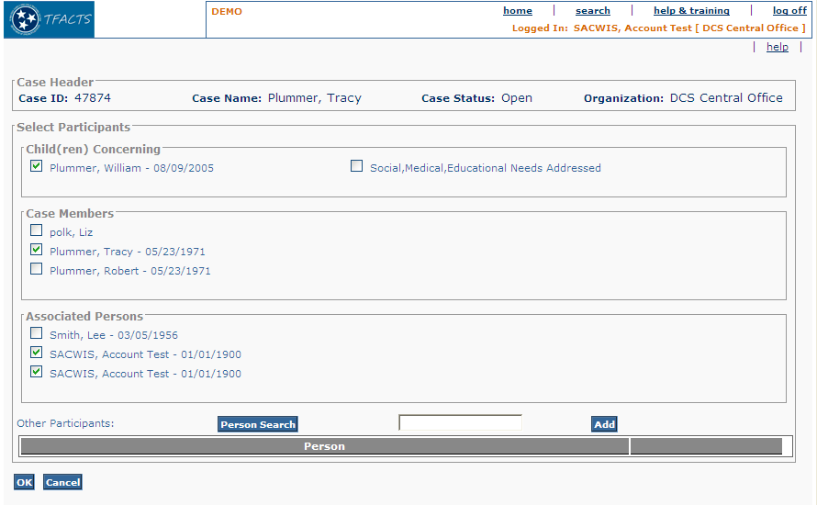

Figure 5 – As Is - Select Participants

To Be – Select Participants Screen

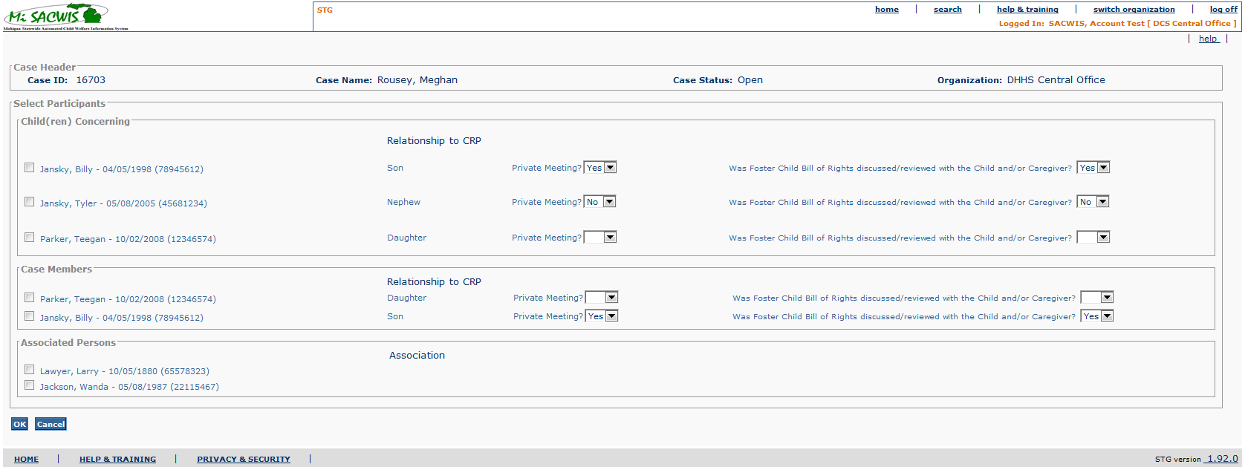

Figure 6 – To Be – Select Participants for Investigation and Case
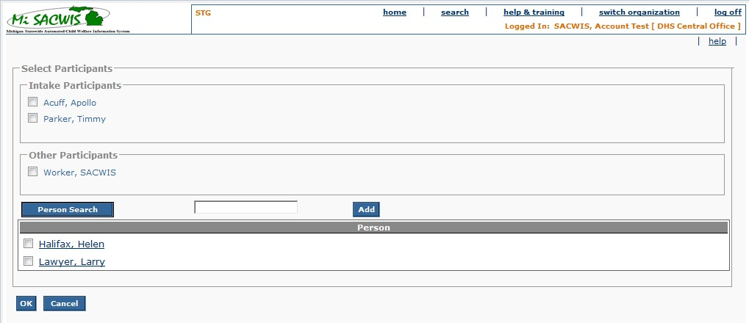

Figure 7 – To Be – Select Participants for Intake

Screen Fields
Status (Unchanged/Add/Modify/Delete) | As Is Class.Attribute Name | To Be Class.Attribute Name | As Is Display Name | To Be Display Name | To Be Type | To Be Align | To Be Size | To Be Read Only | To Be Calculation | To Be Edit Mask | To Be UI Validation
Keep | N/A | N/A | Case Header | Case Header  Or  Intake Header  Or  Investigation Header | Section Header | L | N/A | T | Navigating from Case:  Case Header  Navigating from Intake (IN01): Intake Header  Navigating from Investigation (IV20): Investigation Header | Use Standard Case Header  or Intake Header  Or Investigation Header  Format
Keep | N/A | N/A | Select Participants | Select Participants | Section Header | L | N/A | T
Modify | N/A | N/A | Child(ren) Concerning | Child(ren) | Section header | L | N/A | T
Keep | ActivityLogParticipant.ActivityParticipantId | ActivityLogParticipant.ActivityParticipantId;  Party.PersonID | Name + checkbox +  personId | Name | Check box | L | N/A | F |  | First Name, Last Name; +  concatenated person ID | User entered  Not required  List populated with All Active case members who 18 years of age or less.. See BR 3.3.5.5
Delete | N/A | SmeAddressedFlag.activityParticiapnt | Social, Medical, Educational Needs Addressed + Checkbox | Social, Medical, Educational Needs Addressed + Checkbox | Number | L | N/A | F | Checkbox and label only displayed for Child Concerning Case members. See BR # 8. |  | User selected checkbox(es); For each Child Concerning participant listed is a checkbox
Add | N/A | N/A | N/A | Relationship to CRP | Display text | L | 100 | T |  |  | System derived  The relationship to CRP needs to be established via CM03f- Maintain Relationship Summary
Add | N/A | ActivityLogParticipant.PrivateMeetingCode | N/A | Private Meeting? | Drop down list | L | 6 | F | DomainCode=’YesNo’ |  | User entered
Add | N/A | ActivityLogParticipant.fCBillOfRightsReviewCode | N/A | Was Foster Child Bill of Rights discussed/reviewed with the Child and/or Caregiver? | Dropdownlist | L | 100 | F | DomainCode = ‘YesNo’ | N/A | User Selected  Required if there is an open FC Program Type for the selected participants.  User modifiable
Modify | N/A | N/A | Case Members | Case Members  Or  Intake Participants  Or  Investigation Persons | SectionHeader | L | N/A | T | Dependent on navigation:
Keep | ActivityLogParticipant.ActivityParticipantId | ActivityLogParticipant.activityParticipantId  +  Party.PersonID | Name + checkbox + personId | Name | Check box | L | N/A | F |  | First Name, Last Name ; +  concatenated person ID | User entered  Not required  List populated with all active case members, Intake Participants with a Person ID or Investigation Persons  See BR 3.3.5.5
Add | N/A | N/A | N/A | Relationship to CRP | Display text | L | 100 | T |  |  | System derived  The relationship to CRP needs to be established via CM03f- Maintain Relationship Summary
Keep | N/A | N/A | Associated Persons | Associated Persons | Section header | L | N/A | T
Keep | ActivityLogParticipant.ActivityParticipantId | ActivityLogParticipant.ActivityParticipantId | Name + checkbox | Name | Check box | L | N/A | F |  |  | User entered  Not required  Populate list with all assigned workers + all associated case persons  See BR 3.3.5.5
Add | N/A | NCaseAssociatedPerson.associationCode | N/A | Association | Display Text | L | 30 | T |  |  | System derived  The association needs to be established via CM03c- Maintain Associated Persons
Add | N/A | N/A | N/A | Persons | Section Header | L | N/A | T | N/A | N/A | N/A
Add | N/A | Person.lastName, firstName, middleName | N/A | N/A | Checkbox | L | 100 | T | Where Person.PersonId = the Person.PersonId returned from Person Search | N/A | N/A

Action Buttons/Hyperlinks
Status (Keep/Add/  Modify/Delete) | Label | Type | On Click Action/Navigation
Keep | Person Search | Button | Opens Person search page to search and retrieve person name.
Keep | Add | Button | Moves added participant name to Persons grid.
Keep | OK | Button | Caches data entered, the page closes, and returns the actor to the Social Work Contact Details page.
Keep | Cancel | Button | All cached and uncached data is removed, the page closes, and returns the actor to the Social Work Contact Details page.

Business Rules
No. | Status (Keep/Add/  Modify/Delete) | Business Rule Description | Modified Business Rule | Execution Event (field tab out/save etc) | Error Msg Code  To be completed by Development Team
1 | Modify | If no participant is selected for a case recording, the system must display a warning message to the user to confirm that no participants should be added. | If no participant is selected for a Social Work Contact, the system must display an error message telling the user to add at least one participant. | Apply or save of Social Work Contact detail
2 | Modify | One to many ‘other participants’ can be added to a case recording. | One to many additional participants can be added to a case recording (activityLogParticipant) using Person Search/Add | N/A
3 | Modify | If a person is added as an ‘Other participant’ via retrieving from Person Search, the system should present the person name in the grid as a hyperlink which will navigate the user to the Person Overview page. | If a person is added as an additional participant via retrieving from Person Search, the system will present the person name in the Persons grid as a hyperlink which will navigate the user to the Person Overview page. | On retrieval of name from person search.
4 | Keep | Once selected and OK clicked, the system must display all selected and added participants on the Social Work Contact detail page. |  | Click OK
5 | Modify | The list of case participants to select for case recordings should include all active case members; all case assigned persons; and all associated case persons. Active Case Members who are less than 18 years old or case members whose latest adjudication = ‘Delinquent’ who are equal to or less than 19 years old will be displayed in a separate list of ‘Child(ren) Concerning’. | The list of case participants to select for Social Work Contacts will include  - Navigating from case:  active Case Members  or  Navigating from IV20: Investigation Persons  Or  Navigating from IN01: Intake Participants with a Person ID  - all case assigned persons (in Associated Persons box)  - all other Persons added via Person Search/Add- all non-end dated Associated Persons from an Investigation linked to an Ongoing case are available to be selected as Participants on the ongoing case  - all non-end dated Associated Persons from an original case (Ongoing or Permanent Ward) are available to be selected as Participants when the child is moved to the new case.  - all non-end dated Associated Persons from an Investigation linked to the original Ongoing case are available to be selected as Participants when the child is moved to a new Permanent Ward case. | Open of participant page.
6 | Modify | If navigating to Case Recordings from Investigation case, the list of participants to select includes all investigation participants. There will be no Associated case persons on the Investigation case. The investigation participants will be displayed as Child(ren) Concerning members and Other Investigation Participants in separate group frames as for the ongoing and Adoption Cases. See BR 6 above.  If navigating to Social Work Contacts from the Ongoing Case or the Adoption Case, the list of participants to select includes all active case participants. | There will be no difference in how names in the Select Participants screen will display – regardless of how the user navigates to this screen. | Page open event.
7 | Add | A person selected from the Persons grid will be added to the Social Work Contact as a participant. |  | OK button
8 | Add | If a social work contact is accessed from a Residential record, the case members section will only display case members on the residential record. The Other Participants will only be assigned workers and associated persons attached to the Residential record. |  | Screen Display
9 | Add | Foster Child Bill of Rights dropdown response of Yes or No will be mandatory for all individuals selected in listing under both Child(ren) Concerning and Case Members fields. Only if there are any open FC Program Types for the selected participants. |  | OK button
10 | Add | Foster Child Bill of Rights dropdown should be visible only from case level navigation. |  | Page open event.
11 | Add | During creation of a new SWC a case member will be placed in the Child section in a SWC if:  - The case member is 18 years old and under.  - The case member is over 18 with an open foster care and/or adoption and/or JJ program type.

Screen Navigation
No. | Status (Keep/Add/  Modify/Delete) | To Screen Navigation Path
1 | Keep | Case Overview > select a non Investigations case > Social Work Contact > Add Social Work Contact > Add Participants
2 | Keep | Workload > select an Investigations case > Investigation Topics > Social Work Contact > Add Social Work Contact > Add Participants
3 | Add | Investigation Workload > Social Work Contact > Add Social Work Contact > Add Participants

Pre-Conditions
No. | Status (Keep/Add/  Modify/Delete) | Pre-Condition
1 | Keep | Case must exist in MiSACWIS

Reference Values
No. | Status (Keep/Add/  Modify/Delete) | To Be Class Attribute | Domain Code  (Screen field name) | Short Desc | Ref Data Code
1 | N/A

Social Work Contact Addendum Details Screen

As Is – Case Recording Addendum Details Screen
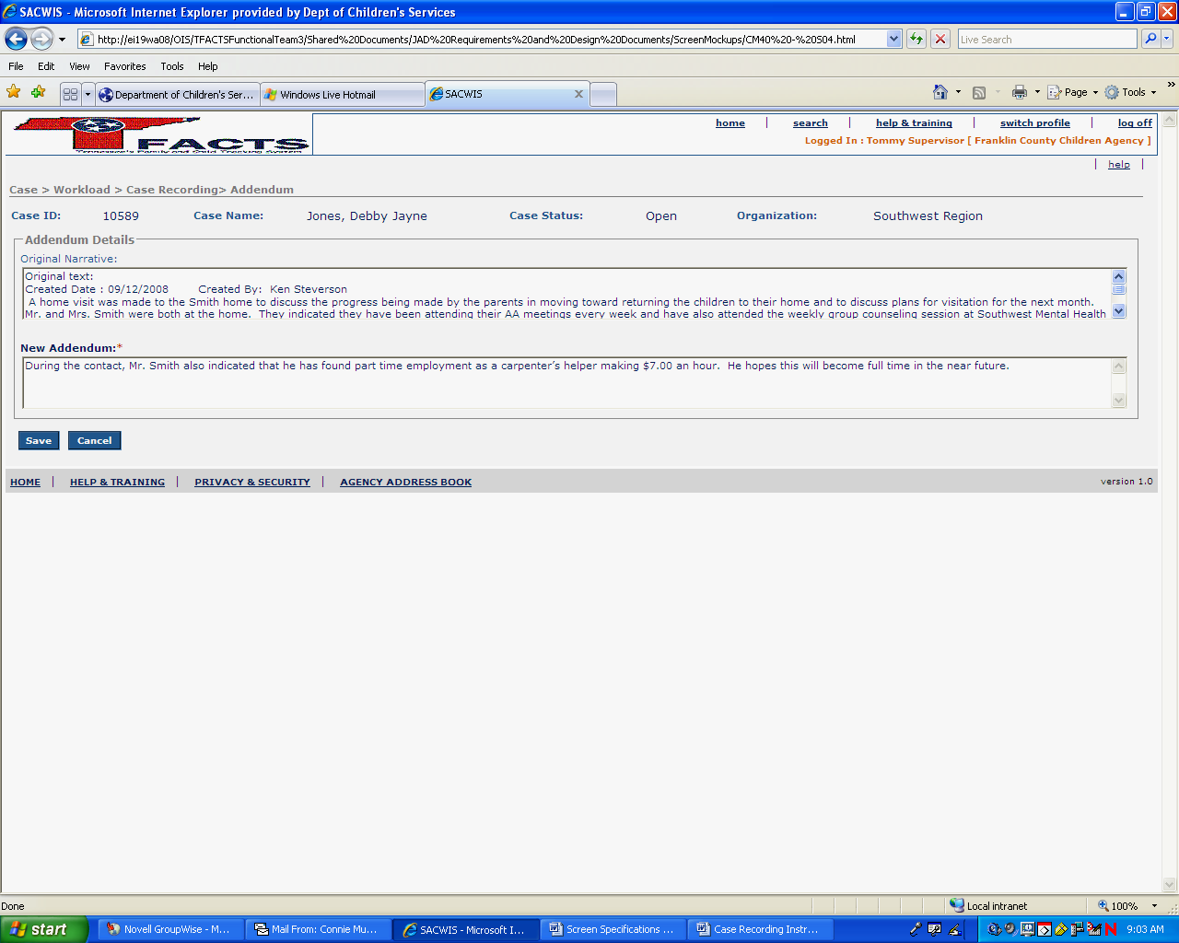

Figure 8 – As Is – Case Recording Addendum Details

To Be – Social Work Contact Addendum Details Screen
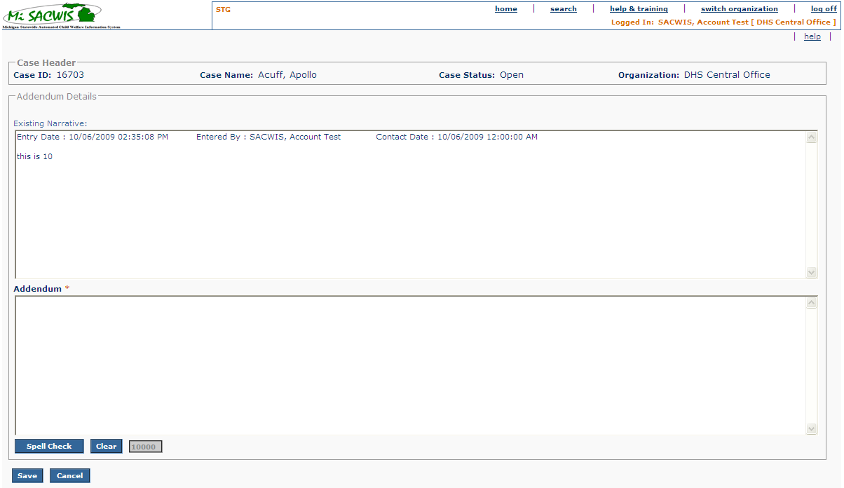

Figure 9 - To Be Social Work Contact Addendum Details

Screen Fields
Status (Keep/  Add/  Modify/  Delete) | As Is Class.Attribute Name | To Be Class.Attribute Name | As Is Display Name | To Be Display Name | To Be Type | To Be Align | To Be Size | To Be Read Only | To Be Calculation | To Be Edit Mask | To Be UI Validation
Keep | N/A | N/A | Case Header | Case Header  Or  Intake Header  Or  Investigation Header | Section Header | L | N/A | T | Navigating from Case:  Case Header  Navigating from Intake (IN01): Intake Header  Navigating from Investigation (IV20): Investigation Header | Use Standard Case Header  or Intake Header  Or Investigation Header  Format
Keep | N/A | N/A | Addendum Details | Addendum Details | Section header | L | N/A | T
Modify | CaseActivityNarrative.ActivityNote | CaseActivityNarrative.ActivityNote | Original Narrative | Existing Narrative: | Text field | L | Clob | F |  |  | User entered  Not Required;
Modify | CaseActivityNarrative.activityNote | CaseActivityNarrative.activityNote | New Addendum | Addendum | Text field | L | Clob | F |  |  | User entered text. Required. No default

Action Buttons/Hyperlinks
Status (Keep/Add/  Modify/Delete) | Label | Type | On Click Action/Navigation
Keep | Spell Check | Button | Runs the spell check functionality in the Narrative textbox.
Keep | Clear | Button | Clears cached an uncached text from the Amendment field. (Note: cannot clear saved text). Clear button is disabled if there is no cached or uncached text.
Keep | Save | Button | All unsaved data is committed to the database, the page closes, and returns the actor to the Social Work Contact Detail page
Keep | Cancel | Button | All cached and uncached data is removed, the page closes, and returns the actor to the Social Work Contact Detail page.

Business Rules
No. | Status (Keep/Add/  Modify/Delete) | Business Rule Description | Execution Event (field tab out/save etc) | Error Msg Code  To be completed by Development Team
1 | Add | The Addendum detail page shall display narrative text from both narrative boxes on the detail screen (the one that prints as well as the one that does not print) + any addendum text – each clearly labeled with  - created date/time  - created by  - Contact date  for each entry.  There will be a demarcation of a dotted line with labels to indicate the three sections:  “Narrative”  “Narrative that will not print on the Service Plan.”  “Addendum”
2 | Keep | One to many Case Recording Addendums can be added to a case recording with a “Completed” or “Completed by System” or “Linked” status | Add Social Work Contact Addendum
3 | Keep | A Social Work Contact Addendum cannot be added to a case recording in draft status. | Add Social Work Contact Addendum

Screen Navigation
No. | Status (Keep/Add/  Modify/Delete) | To Screen Navigation Path
1 | Keep | Case Overview > select a non Investigations case > Social Work Contact > select row > Add Social Work Contact Addendum
2 | Keep | Workload > select an Investigations case > Investigation Topics > Social Work Contact > select row > Add Social Work Contact Addendum
3 | Add | Investigation Workload > Social Work Contact > select row > Add Social Work Contact Addendum

Pre-Conditions
No. | Status (Keep/Add/  Modify/Delete) | Pre-Condition
1 | Keep | Social Work Contact is in Completed Status

Reference Values
No. | Status (Keep/Add/  Modify/Delete) | To Be Class Attribute | Domain Code | Short Desc | Ref Data Code
1 | N/A

View Full Narrative Screen

As Is – Full Narrative Screen
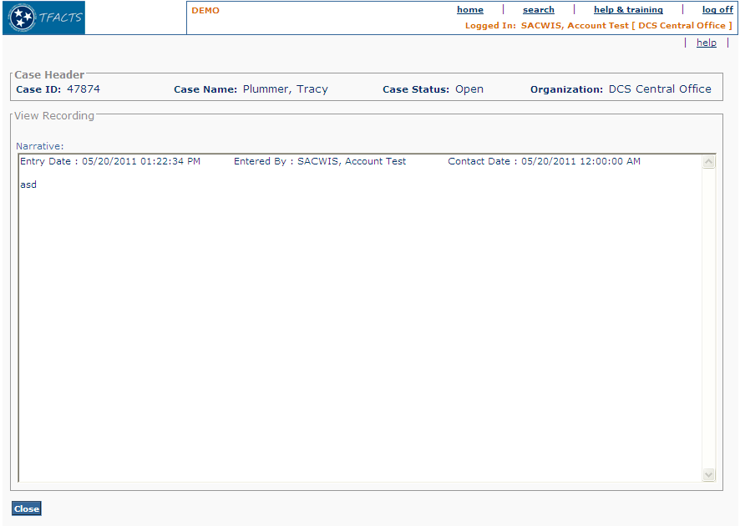

Figure 10 – As Is - View Full Narrative Screen

To Be – View Full Narrative Screen
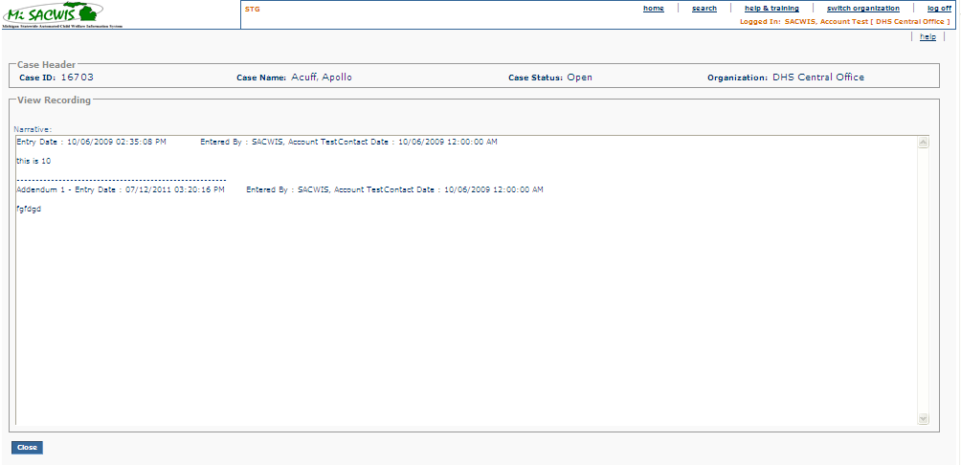

Figure 11 - To Be - View Full Narrative Screen

Screen Fields
Status (Keep/  Add/  Modify/  Delete) | As Is Class.Attribute Name | To Be Class.Attribute Name | As Is Display Name | To Be Display Name | To Be Type | To Be Align | To Be Size | To Be Read Only | To Be Calculation | To Be Edit Mask | To Be UI Validation
Keep | N/A | N/A | Case Header | Case Header  Or  Intake Header  Or  Investigation Header | Section Header | L | N/A | T | Navigating from Case:  Case Header  Navigating from Intake (IN01): Intake Header  Navigating from Investigation (IV20): Investigation Header | Use Standard Case Header  or Intake Header  Or Investigation Header  Format
Keep | N/A | N/A | View Recording | View Recording | Section header | L | N/A | T
Keep | CaseActivityNarrative.ActivityNote | CaseActivityNarrative.activityNote | Narrative | Narrative | Text field | L | Clob | T |  |  | (The narratives in the table for the “activityLogId” have to be queried and appended in the text area based on the sequence they were created in.)

Action Buttons/Hyperlinks
Status (Keep/Add/  Modify/Delete) | Label | Type | On Click Action/Navigation
Keep | Close | Button | Closes page and returns actor to calling page.

Business Rules
No. | Status (Keep/Add/  Modify/Delete) | Business Rule Description | Modified Business Rule | Execution Event (field tab out/save etc) | Error Msg Code  To be completed by Development Team
1 | Modify | The full narrative page shall display all original narrative text + any addendum text clearly labeled with created date and created by name for each entry. | The full narrative page shall display narrative text from both narrative boxes on the detail screen (the one that prints as well as the one that does not print) + any addendum text – each clearly labeled with  - created date/time  - created by  - Contact date  for each entry.  There will be a demarcation of a dotted line with labels to indicate the three sections:  “Narrative”  “Narrative that will not print on the Service Plan.”  “Addendum” | Open Full Narrative page

Screen Navigation
No. | Status (Keep/Add/  Modify/Delete) | To Screen Navigation Path
1 | Keep | Case Overview > select non Investigation Case > Social Work Contact > select Social Work Contact row > View Full Narrative
2 | Keep | Worklaod > select Investigation Case > Investigation Topics > Social Work Contact > select Social Work Contact row > View Full Narrative
3 | Add | Investigation Workload > Social Work Contact > select Social Work Contact row > View Full Narrative

Pre-Conditions
No. | Status (Keep/Add/  Modify/Delete) | Pre-Condition
1 | Keep | A Social Work Contact record has been entered.

Reference Values
No. | Status (Keep/Add/  Modify/Delete) | To Be Class Attribute | Domain Code | Short Desc | Ref Data Code
1 | N/A

